Our Ref: _______________ Your Ref: ________________________ Date: __________________

Baptist Church

Baale Yaku Site Area, P. O. Box 644,

Ogbomoso, Oyo State. Tel. 07052425407

Email: [newsprinbaptistchurch@gmail.com](mailto:newsprinbaptistchurch@gmail.com)

Website: newspringbc.comze.com

NEW SPRING

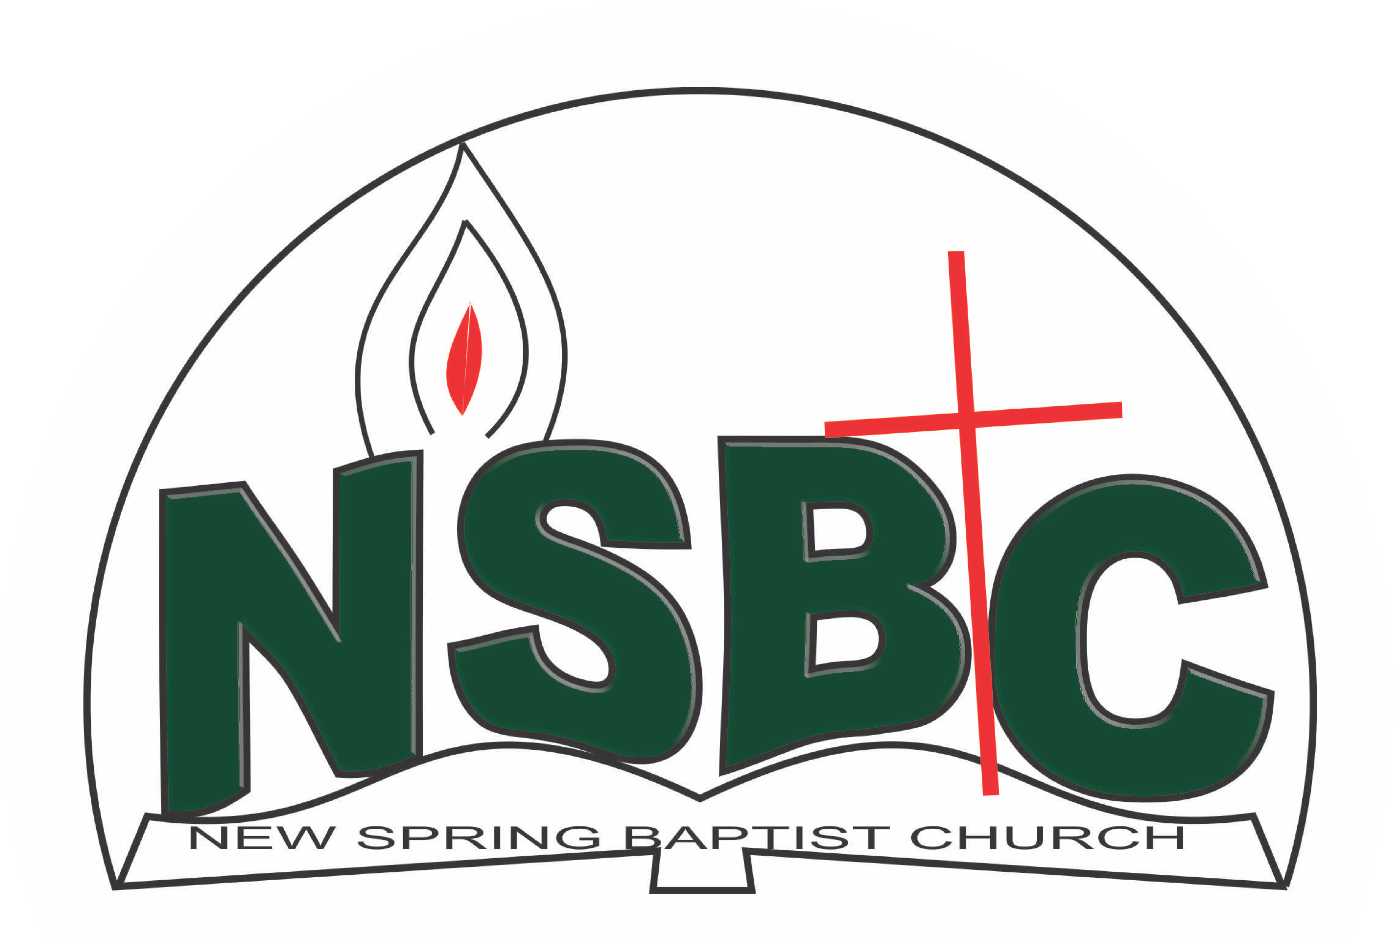

22 January 2022

Dear Dn. Sunbo Olatubosun,

Nomination to Serve as an Officer and Worker in the Church in 2022

Calvary greetings in the precious name of our Lord and Saviour Jesus Christ. It is our pleasure to inform you that, at the Church-in-Conference held on December 19, 2021, the Church ratified your nomination to serve in the following areas between January 1 and December 31, 2022:

1. Member, Building Committee under the chairmanship of Dn. OmoOlorun Olupona
2. Sunday School Superintendent
3. Discipler
4. Chairman, Diaconate .
5. Member, Church Property and Maintenance Committee under the Chairmanship of Mr. Rotimi Adeniyi
6. Member, Intercessor Committee under the chairmanship of Mrs. Funke Oyekunle
7. Member, Waiting & Expecting Couple Committee under the chairmanship of Dn. Dr. OmoOlorun Olupona
8. Member, Church Council
9. Member, Church Ushers under the Chairmanship of Mr. Nathaniel Oyekunle.
10. Member, Benevolence Committee under the leadership of Dns. Oluwayemisi Fatiloro.
11. Member, Nominating Committee under the chairmanship of Dn. Ezekiel Ayinde
12. Member, Counselling & Follow-up Committee under the chairmanship of Dn. Christinana Oketoobo

Please refer to the table below for the key functions of each of these roles. Details can be found in the Church constitution. You are strongly encouraged to become familiar with the tasks as stated in the document. There will be an orientation of the Church workers on January 22, 2022 at 8:30 a.m. on the church premises. Please ensure you participate in this training.

“Now it is required that those who have been given a trust must prove faithful. I Corinthians 4:2”. May God find you faithful in the task He has assigned to you.

| Domain | Key function of Office, Department or Committee |
| --- | --- |
| Building Committee | The purpose of the committee is to safeguard the interest of the Church in any building project the Church embarks upon |
| Sunday School Superintendent | To organized the Sunday School and supervised Sunday School Classes. |
| Discipler | To provide support to the Church Pastor in the ministry of the Church to ensure that members and regular worshippers are well equipped for every good work. |
| Deacons1 | To provide support to the Church Pastor in the effective ministry of the Church to its members, those under spiritual watch care of the Church and the community at large |
| Church Property Committee | The committee is responsible for managing all Church fixed and non-fixed properties |
| Intercessors Committee | The committee is responsible for standing in the gap on behalf of the Church and her members |
| Waiting & Expecting Committee | To provide encouragement, advice and spiritual support for waiting and expecting couples |
| Church Council member | The Church Council is the governing body of the Church whose membership, under the leadership of the Holy Spirit, holds one another mutually accountable with respect and love and sees to the smooth running of the Church. |
| Member, Church Ushers | To provide support to the Church Pastor in guiding members and visitors to appropriate seating locations before and during service |
| Member, Benevolence Committee | The committee is responsible for the implementation of the benevolence policy of the Church. |
| Member, Nominating Committee | The Nominating Committee shall coordinate the staffing of all Church leadership positions that are filled by volunteers. |
| Member, Counsellling& follow-up Committee | To help decision makers understand and follow through on their decisions |

1Deacons are elected in the first instance for 5 years (so you will serve till 2023)

Thank you for accepting to serve in this Church.

Yours in His service,

Olusayo Okediji Blessed Agboola

Church Secretary Chairman, Nominating Committee